Experiment No 03

Program 01: Use of fork() to call child process.

#include<stdio.h>

int main ()
{
fork(); //Calls child process
printf("Hello\n"); //THis is what parent process does
return 0;
}
Output:


Program 02: Calling multiple fork commands.
#include<stdio.h>

int main ()
{
fork();
fork();
fork();
printf("Hello\n");
return 0;
}
Output:
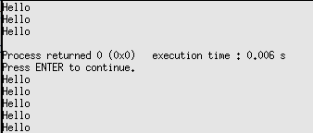

Program 03: Process creation
#include<stdio.h>
int main ()
{
int pid;
pid=fork();
if(pid==0)printf("Child process executing and id is: %d\n",getpid());
else if (pid<0)
{
printf("Error Occurred\n");
exit(-1);
}
else printf("Parent process executing and id is: %d\n",getpid());
return 0;
}

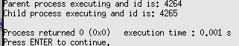
Output:

Program 04: Using sleep command.
#include<stdio.h>
int main()
{
int pid=fork(); //Creating prcocess using fork command
if(pid<0)
{

printf("Process cannot be created\n");
exit(1);
}
else if(pid>0)
{
printf("Process is created\n");
exit(1);
}
else
{
sleep(2);
printf("Child process created\n");
}

return 0;
}
Output:
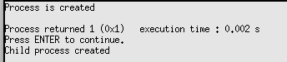

Program 05: Sleep command using getpid function
#include<stdio.h>
int main()
{
int pid=fork(); //Creating child process using fork command
if(pid==0)
{
printf("Child process\n");
//print child process pid
printf("Child Process with pid: %d, ",getpid());
//print it's parents pid
printf("It's Parent Process id: %d.\n",getppid());
//Make thid currently running child to leep for 5s
sleep(5);
printf("Child process after sleep=5\n");
//print child process pid
printf("Child Process with pid: %d, ",getpid());
//print it's parents pid
printf("It's Parent Process id: %d.\n",getppid());
}
else
{
printf("Parent process\n");
sleep(10);

//Parents pid
printf("It's Parent Process id: %d.\n",getppid());
printf("Parent terminated\n");
}

return 0;
}
Output:
